**ASSISTED PRACTICE (SWITCH, MODULE AND INCLUDE CONTROLLERS**)

Switch Controller:

Step1: Record some steps using blazemeter of Heroku app

Step2: Then, Open this recorded file in Jmeter

Step3: Right click on Thread Group -> Add -> Logic controller -> Add three Simpler controllers

Step4: Make separate simple controllers for all of the recorded steps

Step5: Right click on Thread Group -> Add -> Logic controller -> Switch Controller

Step6: In Switch controller, Give switch value as one of the sampler

Step7: Right click on Thread Group -> Add -> Listener -> View Results tree

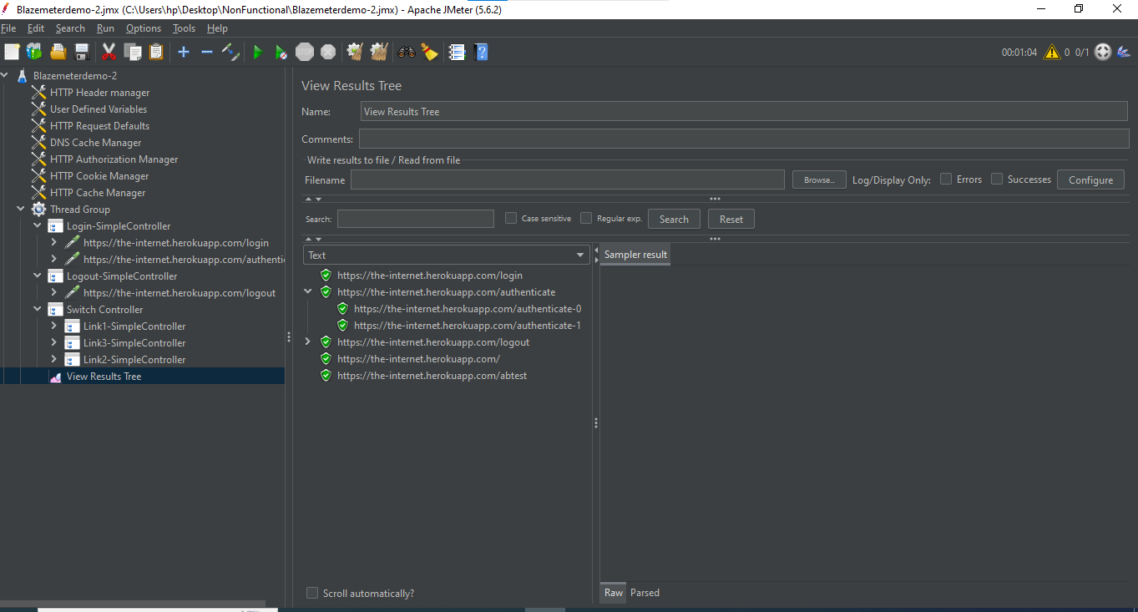

Module Controller:

Step1: Open the Blazemeterdemo-2 Script in Jmeter

Step2: Disable the controllers that we previously added in this Script

Step3: Right click on Thread Group -> Add -> Logic controller -> Module Controller

Step4: Click on Module Controller -> It displays all our scripts and disable controllers of Thread Group -> Select any one of the disable controller that we want to run as shown below:

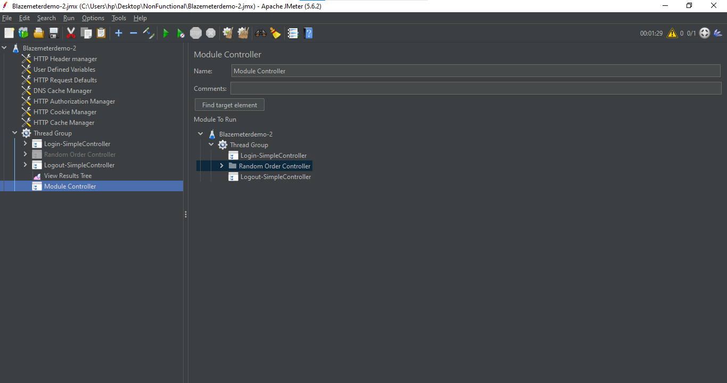

Step5: Right click on Thread Group -> Add -> Listener -> View Results Tree (to see the output )

Step6: Save it and execute

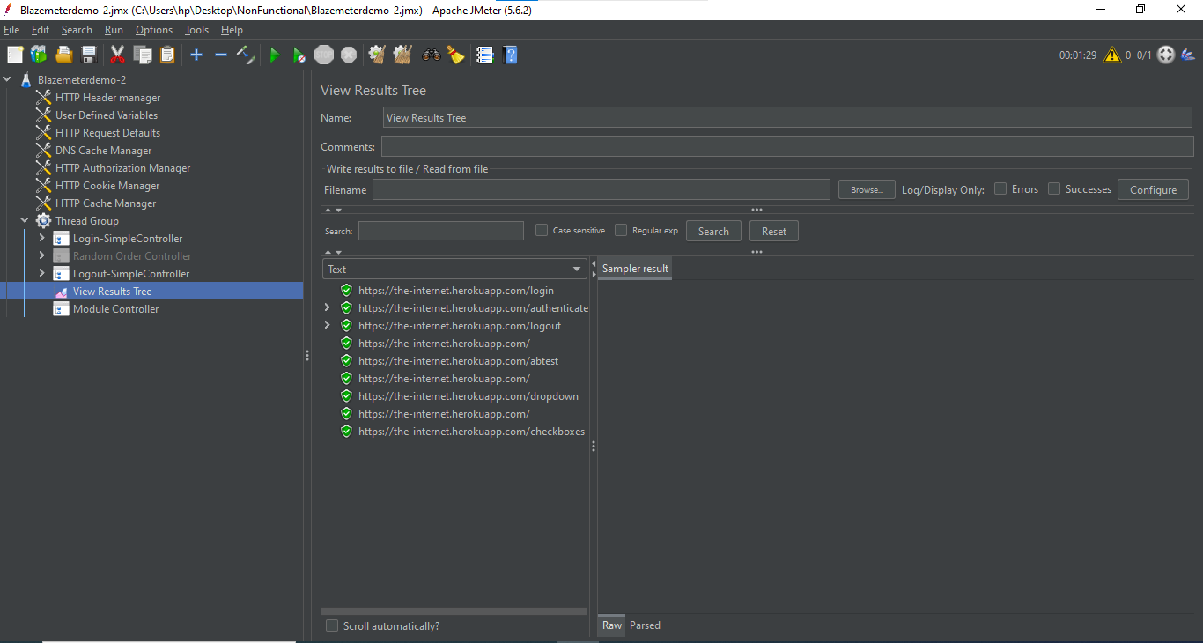

Include Controller:

Step1: Open new Test Plan in Jmeter and Save this plan in folder

Step2: Right click on Test Pan -> Add -> Test Fragment -> Test Fragment

Step3: Right click on Test Fragment -> Add -> Sampler -> HTTP Request

Step4: In HTTP Request, Give the details as shown below:

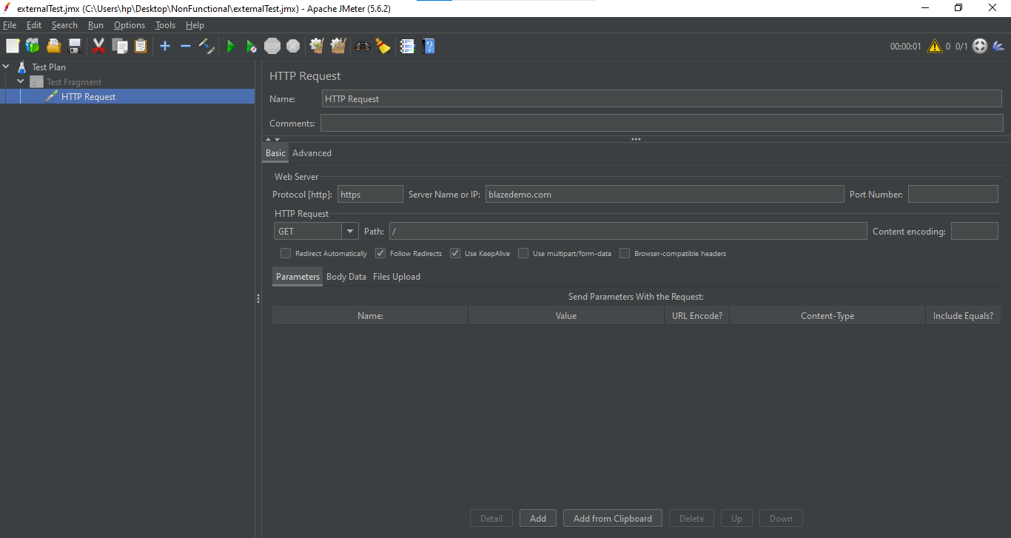

Step5: Open the Blazemeterdemo-2 Script in Jmeter

Step6: Create another Thread Group for Include Controller in that script

Step7: Right click on Thread Group -> Add -> Logic controller -> Include Controller

Step8: In Include Controller, Give the whole path of above file in Filename Section as shown below:

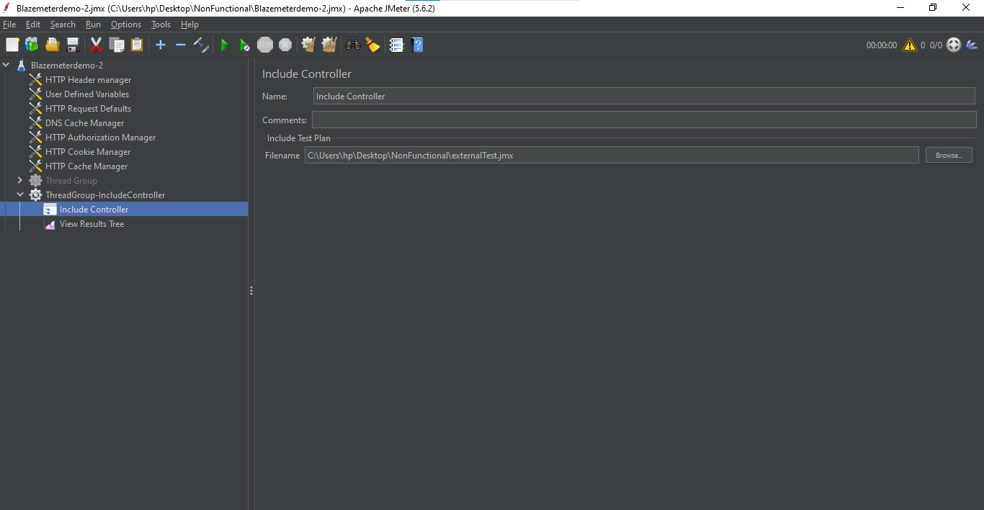

Step9: Right click on Thread Group -> Add -> Listener -> View Results Tree (to see the output)

Step10: Save it and execute

